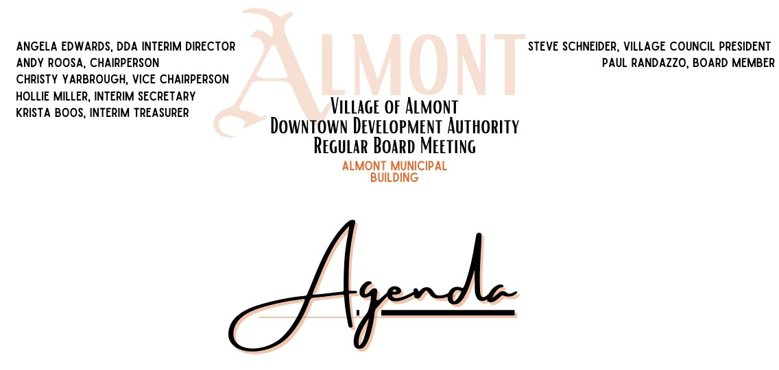

January 25, 2023 - 7:00 PM

**Call to Order**

**Additions/Deletions to Agenda:**

**Communications:** Annual Joint Meeting

The annual joint meeting between the Village Council, Planning Commission and DDA will take place on February 21 at 7:30 PM, all DDA Board members are invited and encouraged to attend this collaborative meeting)

Laura Tandy regarding financials

**Public Comments (Agenda Items):**

**Consent Agenda:**

**Approval of Minutes:**

A. Approval of December 21, 2022 Special Meeting Minutes

**Approval of Bills Payable:**

|  |  |  |  |
| --- | --- | --- | --- |
| **Date** | **Vendor** | **Inv#** | **Total** |
|  |  |  |  |
| 1/1/2023 | Accunet Web Services | 22169 | $493.50 |
| 1/14/2023 | Angela Edwards |  | $126.40 |
| 1/4/2023 | Construction Code Authority | Dec-22 | $61.00 |
| 1/4/2023 | DTE-First Congregational Church |  | $72.14 |
| 12/19/2022 | Hollie Miller |  | $142.84 |
| 10/31/2022 | Landscape Direct.net | 72688 | $127.50 |
| 12/3/2022 | Paul Randazzo |  | $200.00 |
| 1/10/2023 | Touma, Watson, Whaling, Coury & Stremers PC | 55412 | $1,267.50 |
| 12/9/2022 | Touma, Watson, Whaling, Coury & Stremers PC | 55224 | $97.50 |
| 12/5/2022 | Tri City Times |  | $180.00 |
| 12/31/2022 | Village of Almont - Water |  | $223.34 |
| 11/30/2022 | Village of Almont | 22-0001929 | $109.59 |
| 11/23/2022 | Village of Almont | 22-0001923 | $5.97 |
| 1/4/2023 | Village of Almont | 23-0001946 | $146.70 |
| 1/4/2023 | Village of Almont | 23-0001940 | $30.50 |
| 12/1/2022 | Yard Services Inc | 1807 | $1,275.00 |
| 12/31/2022 | Yard Services Inc | 1810 | $300.00 |
| 12/31/2022 | Yard Services Inc | 1779 | $12,545.00 |

**Treasurer’s Report:**

**A. November Balance Sheet**

**B. November Profit & Loss Budget**

**C. November Profit & Loss**

**D. December Check Register**

**E. December Balance Sheet**

**F. December Profit & Loss Budget**

**G. December Profit & Loss**

**Director’s Report:**

**A.** January 2023

**New Business:**

A. Agreement Between Council & DDA for Financials

B. Treasurer Duties/ Signers on Account

C. Lawsuit Update

D. Director Applications

E. Applications for Appointment to DDA Board

F. Historical Walking Tour Signs and Maps

G. Trash Cans

H. Clock Painting

I. Business Surveys

J. New Business Welcome Packet/ DDA Business Brochure

K. Events

**Old Business:**

A. Holly Day Parade

**Public Comments (Non Agenda items):**

**Board Questions and Comments**

**Adjourn**